Application Number | 07/2019/1977/VAR
Address | Unit 3  143 Station Road Bamber Bridge Preston Lancashire  PR5 6LA
Applicant | Mr Mark Bentham
Development | Application for the variation of condition 7 (no external seating or patio heaters) of planning permission 07/2018/3291/FUL
Officer Recommendation  Officer Name | Approval with Conditions  Mrs Janice Crook
Date application valid | 01.03.2019
Target Determination Date | 26.04.2019
Extension of Time

Location Plan

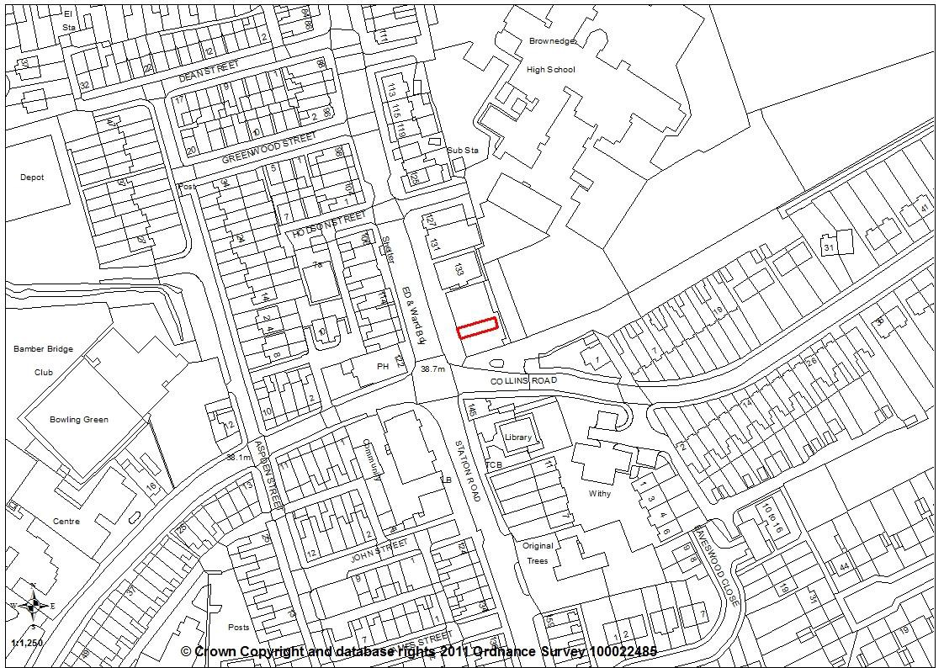

Report Summary

1.1 Members may recall a report that came before planning committee at its 18 July 2018 meeting relating to Unit 3, 143 Station Road, Bamber Bridge. The application was for a change of use of a vacant A1 retail premises to a drinking establishment, a micro-pub, within the A4 Use Class.

1.2 On consideration of that proposal, Environmental Health there was only limited potential to impact on neighbouring properties and therefore recommend conditions be imposed and as such the application was approved.

1.3 Condition 7 specified that there be no external seating or patio heaters outside the venue. This was in the interests of the amenity of the nearby residents in terms of noise and disturbance.

1.4 This current application seeks to remove condition 7 to allow for external seating on the front forecourt onto Station Road. The application is silent on proposals to introduce any patio heaters.

1.5 It is considered that the proposal for external seating with a limit to the hours of use is acceptable. However, Environmental Health do not want to see the use of patio heaters and therefore it is recommended that two conditions are imposed, one to limit the hours of use of the external seating area and one to prevent the use of patio heaters. With the inclusion of these condition it is considered the proposal is acceptable and the application is recommended for approval.

Site and Surrounding Area

2.1 The application site was a vacant commercial property Unit 3, within a terrace of commercial premises at 143 Station Road. The terrace is located on the eastern site of Station Road in Bamber Bridge, close to the crossroads junction of Station Road, Collins Road and Brownedge Lane. The unit was previously been used as an A1 retail premises for domestic appliances and has now been converted to a micro pub known as the Beer Box.

Planning History

07/1983/0457 Alterations to shop front. Approved 24/08/1983
07/1986/0524 New shop front. Approved 22/10/1986

07/2018/3291/FUL for a change of use of former shop (Class A1 retail) to drinking establishment (Class A4 Drinking Establishment). Approved 19/07/2018

Proposal

4.1 The application seeks the removal of condition 7 of planning approval 07/2018/3291/FUL which specified: “There shall be no external seating or patio heaters outside the venue.” This was in the interests of the amenity of the nearby residents and to be in accordance with Policy 17 of the Central Lancashire Core Strategy.

4.2 The removal of condition 7 would allow for the use of the front forecourt for tables and chairs with a Tensar barrier extending 3.4m from the front elevation of the premises for a width of 4.2m.

Summary of Publicity

5.1 Neighbouring properties were notified and a site notice posted with no letters of representation being received.

Summary of Consultations

6.1 County Highways have no objections to the proposed development and are of the opinion that the proposals should have a negligible impact on highway safety and capacity within the immediate vicinity of the site. The proposed seating area is located outside of the adopted highway and would not have a negative impact on pedestrian movements along the existing footway.

6.2 Environmental Health have concerns over the potential impact of using the suggested outdoor area, and hence the reasoning behind the original condition. However, the establishment has now been open for some time with no reported problems to the Environmental Health department. Given the location of the site and the fact that other nearby licensed establishments operate with outdoor seating areas, EH do not object to the application in principle. However, they do object to the full removal of condition 7 as detailed within the application form. Instead they request that the condition is amended to read:

‘There shall be no external patio heaters outside the venue’

6.3 An additional condition should also be added to limit the times external seating is allowed.

‘External seating shall only be made available outside the venue between the hours of 12:00 noon and 22:00 on any day’

Policy Background

7.1 Policy B1: Existing Built-up Areas permits development proposals for the re-use of undeveloped and unused land and buildings, or for redevelopment, provided that the development complies with the requirements for access, parking and servicing; is in keeping with the character and appearance of the area; and will not adversely affect the amenities of nearby residents.

7.2 Core Strategy Policy 26: Crime and Community Safety aims for reduced levels of crime and improved community safety through a number of measures, as follows:
- Working with the police, community safety partnerships and other agencies to coordinate analysis and action.
- Encouraging the inclusion of Secured by Design principles in new developments.
- Providing adequate leisure and community facilities or activities, particularly in high crime areas, and especially for young people.
- Aiming to achieve a complementary mix of uses in the City and key service centres with appropriate controls over entertainment uses, taking account of the local authorities’ Statement of Licensing policies.

Material Considerations

8.1 The application property is within a row of 6 shops, all of uniform size and design. Adjacent properties include an Age Concern shop and hot food takeaway to the south and a florist, laundry and accountants to the north with a Spar convenience store beyond. On the opposite side of Station Road is the Withy Arms public house with four residential properties, a hairdressers and tanning studio. To the rear is the Brownedge St Mary’s RC High School. The area is therefore considered to a mixed use area and the change of use of the premises to a drinking establishment was therefore considered appropriate within the area. The premises has opened and is trading as ‘The Beer Box’.

8.2 The proposal now relates to the front forecourt area on Station Road which has recently been re-paved. The applicant wants to place tables and chairs on this forecourt area and has provided a supporting statement, as follows:

“An important step in our business development and a core part of our business plan in year 1 is to be able to have a small outdoor seating area which will be critical to our success particularly as the weather improves in Spring and Summer. Bamber Bridge has recently benefited from significant council investment to upgrade and widen the pavement areas along Station Road. This has seen the area directly outside the Beer Box double in width. This additional space would allow the introduction of a small and neat seating area directly outside the Beer Box whilst continuing to provide sufficient safe areas for pedestrians to pass the shop fronts.

In previous conversations with local Councillors they have indicated that they would like to see a pavement café culture in Bamber Bridge, similar to that you see on the continent and more recently introduced to cities and towns in the UK. We now offer a selection of coffee, teas and other hot drinks from 12pm every day, in addition to our range of beers, and it would be nice for local residents to be able to enjoy their drinks outside in the nicer weather. Outdoor seating is crucial to our survival and success during the summer months, not having this would put us at a significant competitive disadvantage with other local bars who all have outdoor seating. Our customers have told us they are looking forward to us having outdoor seating and are very supportive of our application.”

8.3 County Highways have no objections, commenting that the proposed seating area is located outside of the adopted highway and would not have a negative impact on pedestrian movements along the existing footway. They are also of the opinion that the proposals should have a negligible impact on highway safety and capacity within the immediate vicinity of the site.

8.4 Environmental Health do have concerns over the potential impact of using the suggested outdoor area, and hence the reasoning behind the original condition 7. However, they report that the establishment has now been open for some time with no reported problems to the Environmental Health department. Given the location of the site and the fact that other nearby licensed establishments operate with outdoor seating areas, they do not object to the application in principle.

8.5 Environmental Health do object to the full removal of condition 7 as detailed within the application form in respect of the patio heaters. Instead they request that the condition is amended to ensure that there are no external patio heaters outside the venue, due to their polluting impacts.

8.6 Environmental Health also consider an additional condition should be imposed to limit the times external seating is allowed to be used and suggest from 12 noon when the premises opens until 22:00 which is a similar time to the premises opposite.

Conclusion

9.1 It is considered that the proposal to remove condition 7 is acceptable only to the extent that external seating can be introduced to the front forecourt area, providing it is limited to use until 22:00 only. Therefore it is recommended that the application is approved and condition 7 is removed with two further conditions being imposed, one to control the hours of use of the external seating area and one to prevent the use of external patio heaters.

RECOMMENDATION:

10.1 Approval with Conditions.

RECOMMENDED CONDITIONS:

- The development hereby permitted must be begun not later than the expiration of three years from the date of planning permission 07/2018/3291/FUL that is 19.07.2018
REASON: Required to be imposed pursuant to Section 91 of the Town and Country Planning Act 1990.
- The development, hereby permitted, shall be carried out in accordance with the submitted approved plans Dwg Proposed Plan and Front Elevation (un-referenced); BB-SK01 Proposed Outside Seating Area.
REASON: For the avoidance of doubt and to ensure a satisfactory standard of development.

- The use of the premises hereby approved shall be restricted to the hours as applied for of 12:00 Noon until 23:30 Monday to Friday; 12:00 Noon to Midnight on Saturday and 12:00 Noon to 23:00 on Sundays and Bank Holidays,
REASON: In the interests of the amenities of adjoining residents and to accord with Policy 17 in the Central Lancashire Core Strategy.

- No deliveries or waste collection shall be received by the site between the hours of 22:00 and 07:30 Monday to Friday, 09:00 and 13:00 Saturdays. No deliveries or waste collection shall be received on Sundays or nationally recognised Bank Holidays.
REASON: In the interests of the amenity of the nearby residents in accordance with Policy 17 of the Central Lancashire Core Strategy.

- No live music shall be played at the venue.
REASON: In the interests of the amenity of the nearby residents in accordance with Policy 17 of the Central Lancashire Core Strategy.

- Prior to first use of the premises herby approved, a sound limiter device shall be fitted. Details of the device shall be submitted to the local planning authority, once agreed all amplified audio shall be played through the limiter. The limiter shall be set to ensure that the resulting sound cannot be heard at neighbouring properties. On the receipt of any complaints to the local authority relating to sound emissions from the development then the limiter shall be set to the requirements of the Environmental Health Department of the local authority.
REASON: To safeguard the amenities of neighbouring properties in accordance with Policy 17 of the Central Lancashire Core Strategy.

- There shall be no external patio heaters outside the venue.
REASON: In the interests of the amenity of the nearby residents in accordance with Policy 17 of the Central Lancashire Core Strategy.

- External seating shall only be made available outside the venue between the hours of 12:00 noon and 22:00 on any day.
REASON: In the interests of the amenities of adjoining residents and to accord with Policy 17 in the Central Lancashire Core Strategy

RELEVANT POLICY

Local Plan Policy B1: Existing Built-Up Areas

Core Strategy Policy 26: Crime and Community Safety

